Sudan and South Sudan on brink of all-out war
By Peter Goodspeed, National Post
19 April 2012
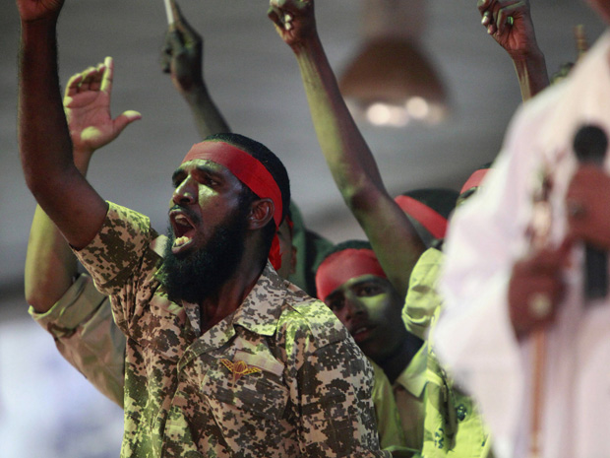
Mohamed Nureldin / Reuters
Supporters stand behind Sudanese President Omar al-Bashir as he speaks at a rally in Khartoum Tuesday.

No one is even trying to maintain the pretense of peace in Sudan and South Sudan these days. Sporadic skirmishes and border shootouts are on the verge of becoming all-out war and the threat is resurrecting fears of a Darfur-like disaster for 10s of thousands of refugees.
A day after South Sudan, Africa’s youngest state, became the 188th member of the International Monetary Fund on Wednesday, the Arab League was scrambling to call an emergency meeting into the growing violence between Sudan and South Sudan.
South Sudanese troops continue to occupy the oil town of Heglig, on the disputed border of South Kordofan state, fighting off air raids by Sudanese jets and counter-attacks by the Sudanese army.
Sudan’s President Omar al-Bashir, dressed in an army uniform plastered with battle ribbons and medals, travelled to the capital of North Kordofan Thursday and praised the revival of a “spirit of jihad” in his country, while vowing to wage a “decisive battle” against South Sudan.
Troops from both countries staged border battles in at least four locations Thursday in some of the worst fighting to plague the region since two million people died during two decades of civil war between 1983 and 2005.
“Sudan and South Sudan are teetering on the brink of all-out war from which neither would benefit,” the Brussels-based International Crisis Group says in a report released Thursday. “Increasingly angry rhetoric, support for each other’s rebels, poor command and control and brinkmanship, risk escalating limited and contained conflict into a full-scale confrontation.”
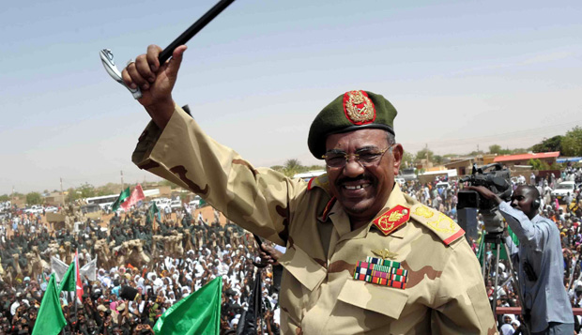
EBRAHIM HAMID/AFP/Getty Images
Sudanese President Omar al-Bashir during his visit to the Northern Kordofan town of El-Obeid Thursday.

Less than a year after Sudan and South Sudan agreed to separate, their fragile peace has been shattered by a failure to resolve their post-secession security arrangements, borders, citizenship rules or income-sharing arrangements on oil exports.

Peace talks in Ethiopia have foundered and the conflict widened when Sudan used force to seize control of the disputed Abyei region last May and began using local militias to drive nearly 80,000 Nubian refugees from South Kordofan and the Blue Nile areas.

When Sudan arbitrarily imposed stiff transit fees on South Sudan to ship oil through a northern pipeline to Port Sudan, South Sudan shut down its entire 350,000-barrel-a-day oil industry in January and began negotiations with Kenya to build a new pipeline to the port of Lamu, through Ethiopia and Djibouti.

Oil exports had supplied South Sudan with 98% of its government budget and provided Sudan with 55% of its national revenues.

Sudan had its oil revenue cut in half when South Sudan seceded, but it continued to export oil from Heglig, which accounted for 50% of its remaining oil revenue.
That income was abruptly cut off when South Sudan attacked and seized the oil town on April 10, claiming Khartoum was using it as a base from which it staged air and militia raids on the south.
Now, Gen. Bashir is threatening all-out war to regain Heglig.
“These people don’t understand and we will give them the final lesson by force,” he told troops preparing to depart to the South Sudan border on Thursday. “We will not give them an inch of our country and whoever extends his hand on Sudan, we will cut it off.”
The war of words, piled on top of decades of mutual distrust and bad faith, now threatens to reopen Africa’s longest-running civil war.
“A game of ‘chicken’ appears to be underway, in which both sides embark on risky strategies in the hope that the other will blink first. If neither does, the outcome will be disastrous for both,” the International Crisis Group said.
The United Nations, the United States and the European Union have all criticized South Sudan’s occupation of Heglig and denounced Sudan’s continuing air strikes against South Sudan. But there is little sign of a possible diplomatic breakthrough.
Gen. Bashir, who is already wanted by the International Criminal Court for crimes against humanity in Darfur, may now be fighting for his political life in Sudan.
The country’s economy has tanked since South Sudan separated and he is struggling with separate insurrections in Darfur, South Kordofan and Blue Nile.
Given the track record of last year’s Arab Spring, he may well fear open rebellion in Khartoum.
“Bashir’s fall could trigger a wild scramble by multiple armed actors for control of Khartoum and other parts of the country that would be hard, if not impossible, to restrain,” the International Crisis Group warned Thursday.
Still, if northern and southern parts of Sudan return to war, many experts believe the new conflict could be among Africa’s worst.
“Given the brutally indiscriminate ways in which Khartoum has previously chosen to wage war on the people of the South — as well as of Darfur, Blue Nile, and South Kordofan — we should expect huge civilian casualties, massive human displacement, and intolerable assaults on civilians in the North who are ‘ethnically Southern,’ ” said Eric Reeves, a Sudan researcher and analyst from Smith College in Massachusetts.
© 2012 National Post, a division of Postmedia Network Inc. All rights reserved. Unauthorized distribution, transmission or republication strictly prohibited.

