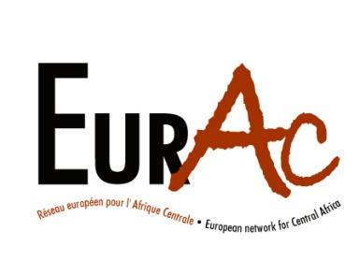

Brussels, May 16th 2010

EurAc sends an election observation mission to Burundi

This Sunday 16 May 2010 EurAc Policy Officer Donatella Rostagno has set off to Burundi together with a group of activists, staff members and volunteers from the member organisations of EurAc, the network of European NGOs working in Central Africa. They will be there for Burundi’s communal elections as part of an observation exercise put in place by Cosome, a coalition of Burundian civil society to monitor elections. The 18 strong EurAc delegation includes five nationalities. It is EurAc’s fourth election mission: previous ones were for the legislative elections in Burundi in 2005 and the two rounds of the Congo elections in 2006.

Through this mission the objective of EurAc and its members is to act in solidarity with Burundian civil society and strengthen its efforts. We believe that in this way we can contribute to the freedom and transparency of the electoral cycle which, if it goes well, will enable Burundi finally to end the era of conflict and to concentrate on good governance and the fight against poverty. The EurAc member organizations will work on these themes in collaboration with their partners in the Burundian civil society.

We are concerned about the various manifestations of violence and intimidation in the country but we remain optimistic that they will not become widespread. We believe that the people of Burundi will have the calm strength and maturity to resist any possible attempts to gain support by those who would like the country to descend into violence once again.

For further information contact:

Donatella Rostagno (in Burundi)+32.496.074905
Kris Berwouts (in Brussels) +32.485.070852

For further details:
Kris Berwouts
Rue des Tanneurs, 165 B - 1000 Brussels, Belgium
Tel: +32 (0)2 213 04 000
@: kris.berwouts@eurac-network.org
www.eurac-network.org

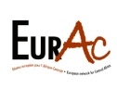

is the European Network of Active NGOs in Central Africa. EurAC is made up of 49 member-organisations
from 13 European countries.

